JK Lakshmipat University

Fundamentals Of Automation-II
ES1113

Project Report

Submitted by:
Lakshya Choudhary (2022BTech053)
Mudit Lodha (2021BTechCSE151)
Yash Tatawat (2022BTech114)

Submitted to:
Dr. H.P. Agarwal
Dr. Pushpendra Singh
Mr. Divanshu Jain

Lab Faculty:
Mr. Ragesh Bhatt
Mr. Anil


May 10, 2023

Problem Statement
All over India, water has to be stored in large tanks in homes in order to be used during the day. The supply of water comes from the municipality and is usually turned on early in the morning around 4 or 5 am. Our project aims to automate the system receiving water, eliminating the need to wake up and do it manually every day, and also make it such that it is affordable and energy efficient.
Introduction
In typical Indian households, there are 2 tanks. There is a larger tank used for storage, typically underground, and a elevated tank that supplies water to the house. The purpose of elevation is to avoid using a pump throughout the day. The purpose of having the large tank is to store water that comes in from the municipality, since it does not supply 24/7. The large tank is not elevated since the weight might cause issues in residential structures.
The norm is to wake up when the municipality turns on the supply and turn on the motor to receive water, which is typically at 4 or 5 am. Then, one must also remember to turn the motor off. Furthermore, a second motor is required to pump water to the second tank so that it can be used.
With our design, the whole system is automated, so that water is automatically pumped when the municipality supplies it and to the second tank when it is near empty. Furthermore, we only use one motor, saving costs as well.
Circuit Diagram
The figure below shows the circuit diagram of our project. The Arduino NANO is connected to the various sensors and actuators as labeled. The relay connects to an external source to bring power to the pump. The power and ground pins of the sensors and actuators are connected to the arduino, but not shown for clarity of the diagram.
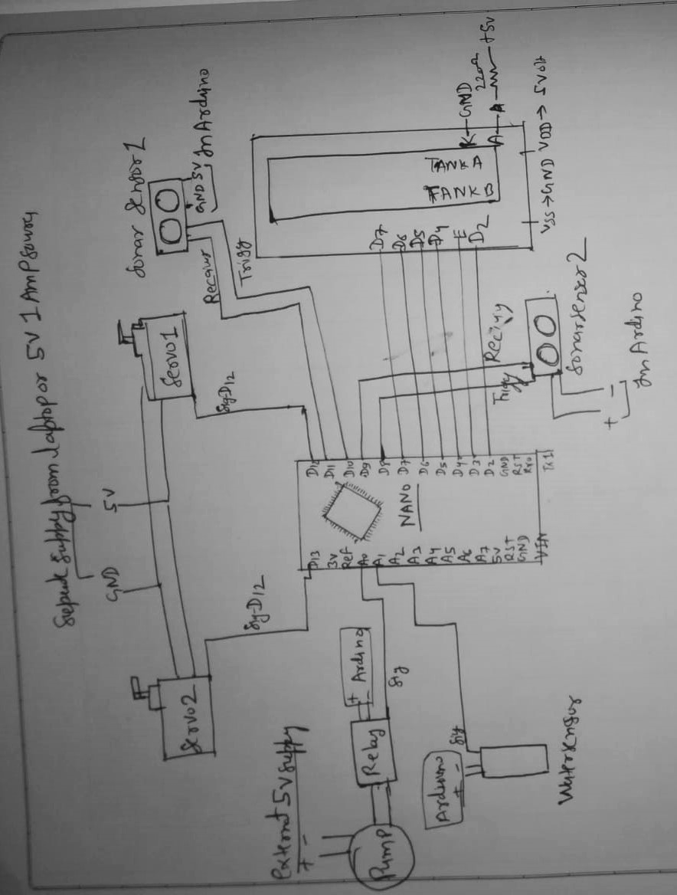

Block Diagram
This diagram shows the functioning of the project with regards to the sensors and actuators. The water sensor has a binary reading, of 0 if there is no water, 1 if there is water. The values for the tank sensor are as following:
- <8: tank is full
- >=8: tank is not full
- >12: tank is empty
- <=12: tank is not empty
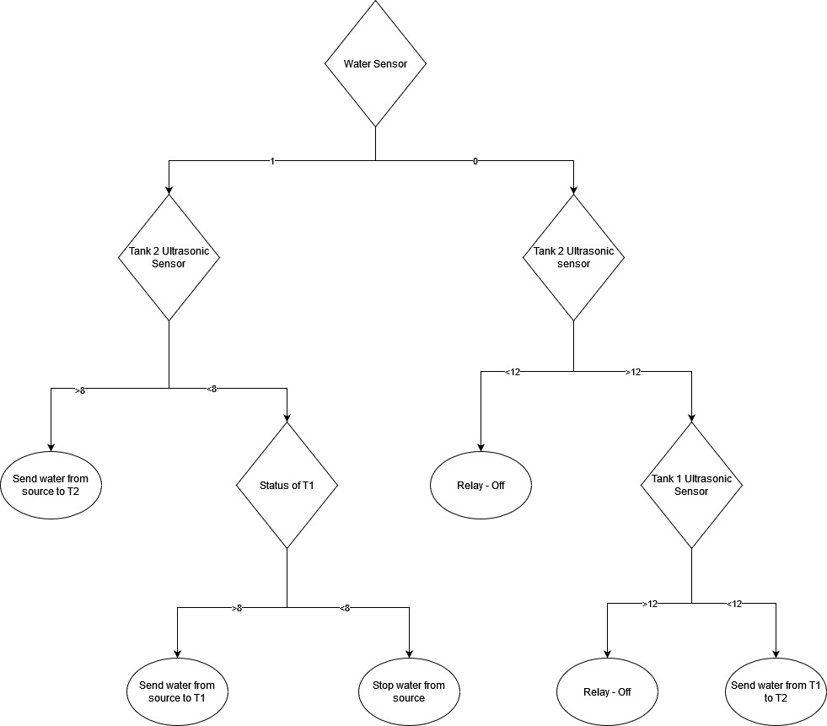

Working
This system uses an Arduino Nano, connected with three sensors and three actuators, namely one water sensor, two ultrasonic sensors, two servo motors and a relay. The use of each is the following:
- Water Sensor - Detect if municipality is supplying water.
- Ultrasonic Sensors - Detect the level of water in the tank.
- Servo Motors - Control the flow of water through threeway valves.
- Relay - Turns on the power supply to the motor that pumps water.
In initial case working of this project is that when ever municipality water comes, it is sensed by the water sensor and Arduino turns servo operated valves in tank one if it is empty and turn on the water pump. Then if tank A is fully filled which is detected by the height sensor (ultrasonic sensor) and municipality water supply is still going on, the Arduino turns servo operated valves towards tank B to fill it. and after both the tanks get filled, it turn off the pump.
In second case if no municipality water is coming and tank B is empty then Arduino checks if tank A is filled more than half, if it is true then it turns servo valve connection from tank A to tank B and turn on the motor so that sufficient water is filled in tank B.
In all the conditions display shows the level of tank A and tank B in bar form.
For this we needed Arduino to work simultaneously on both display and servo function but Arduino cannot be made to multitask. performs tasks line wise which is lengthy and time consuming, so we need to perform task in Arduino simultaneously in another way make which is not meant in Arduino so we used special method that mimics multitasking in Arduino that is perform each task from the time Arduino powered on. Parallel tasking is done.
Results and Analysis
The system was tested and validated under different scenarios, including all of the ones shown in the block diagram. The system was successful in all of those test cases.
We found it suitable to be implemented in households. Even at larger scales, such as industry or commercial use, this system works efficiently. The primary benefit is the automation; no human input is required other than maintenance and servicing. When water comes in from the supply, it is automatically pumped into the tanks. It is also automatically pumped from one tank to the other as needed.
The cost of this system, when implemented on a domestic scale is just under Rs.4000. This is reduced due to only using one motor for the entire system, which is the most expensive part.
The power consumption of the system is also low, and it can be connected to a small solar panel to make it independent from the household power supply. Thus, our goal of making the system energy efficient is achieved.
Furthermore, an LCD display shows the level of water present in tanks.
Overall, the analysis of the system indicates that it is effective, efficient, and affordable for Indian households, providing a cost-effective and reliable solution for the water supply system.
References
For parallel task explaining video:
Youtube
Channel name Mario’s idea
https://www.youtube.com/watch?v=dCku8BabPx4&t=331s
Website
Arduino
https://www.arduino.cc/en/software

Code
# include <LiquidCrystal.h>

LiquidCrystal lcd(2,3,4,5,6,7);
int p;//tank a
int q;// tank b
byte one[] = {
B10000,
B10000,
B10000,
B10000,
B10000,
B10000,
B10000,
B10000
};
byte five[] = {
B11111,
B11111,
B11111,
B11111,
B11111,
B11111,
B11111,
B11111
};
byte four[] = {
B11110,
B11110,
B11110,
B11110,
B11110,
B11110,
B11110,
B11110};
byte three[] = {
B11100,
B11100,
B11100,
B11100,
B11100,
B11100,
B11100,
B11100};
byte two[] = {
B11000,
B11000,
B11000,
B11000,
B11000,
B11000,
B11000,
B11000};

unsigned long previousMillis1 = 0;
const long period1 = 1000;
unsigned long previousMillis2 = 0;
const long period2 = 1000;

#include <Servo.h>
Servo servo_1;
Servo servo_2;
const int Relay=A0; // A0 - Relay

int ST1=8; // sonar 1 Trigger
int SR1=9; // sonar 1 Receiver

int ST2=10; // D11 sonar 2 receiver
int SR2=11; // D11 sonar 2 receiver

int Water_sensor=A1; // A1- water sensor

void setup() {
// for LCD//////////////
lcd.begin(16,2);
lcd.createChar(1,one);
lcd.createChar(5,five);
lcd.createChar(3,three);
lcd.createChar(2,two);
lcd.createChar(4,four);
//////////////////////////

servo_1.attach(12); // D12- servo 1
servo_2.attach(13); // D13- servo 2
pinMode(Relay,OUTPUT);
pinMode(ST1,OUTPUT);
pinMode(ST2,OUTPUT);
pinMode(SR2,INPUT);
pinMode(SR1,INPUT);

//LED LAD LID
pinMode(A4,OUTPUT);
pinMode(A3,OUTPUT);
pinMode(A2,OUTPUT);
pinMode(A1,INPUT);

Serial.begin(9600);

}

void loop() {
int W=analogRead(Water_sensor);
// delay(500);
//Distance A

digitalWrite(ST1, LOW);
delayMicroseconds(2);

digitalWrite(ST1, HIGH);
delayMicroseconds(10);
digitalWrite(ST1, LOW);

int durationA = pulseIn(SR1, HIGH);
int distanceA = ((durationA * 0.034 / 2)-4); // Calculate the distance in centimeters

Serial.print("Distance_A: "); // Print the distance in centimeters
Serial.print(W);

Serial.println(" cm");

//Distance_B
digitalWrite(ST2, LOW);
delayMicroseconds(2);

digitalWrite(ST2, HIGH);
delayMicroseconds(10);

digitalWrite(ST2, LOW);

int durationB = pulseIn(SR2, HIGH);
int distanceB = ((durationB * 0.034 / 2)-3); // Calculate the distance in centimeters

Serial.print("Distance_B: "); // Print the distance in centimeters
Serial.print(distanceB);
Serial.println(" cm");

unsigned long currentMillis = millis();
/////very essential to update display

if (currentMillis - previousMillis1 >= period1) {
previousMillis1 = currentMillis;
lcd.clear();

lcd.setCursor(11,0);
lcd.write("tank1");
p=100-(100*distanceA/10);
for(int i=0;i<=p/10;i++){
if (p%10==0){
lcd.setCursor(i,0);
lcd.write(byte(5));
}
else if (p>10&&p%10!=0){
if((p%10==2)||(p%10==1)){
lcd.setCursor(i,0);
lcd.write(byte(5));
lcd.setCursor(i+1,0);
lcd.write(byte(1));
delay(1);
}
else if((p%10==4)||(p%10==3)){
lcd.setCursor(i,0);
lcd.write(byte(5));
lcd.setCursor(i+1,0);
lcd.write(byte(2));
delay(1);
}
else if((p%10==6)||(p%10==5)){
lcd.setCursor(i,0);
lcd.write(byte(5));
lcd.setCursor(i+1,0);
lcd.write(byte(3));
delay(1);}

else if((p%10==8 )||(p%10==7)){
lcd.setCursor(i,0);
lcd.write(byte(5));
lcd.setCursor(i+1,0);
lcd.write(byte(4));
delay(1);
}
else if((p%10==9)||(p%10==0)){
lcd.setCursor(i,0);

lcd.write(byte(5));
lcd.setCursor(i+1,0);
lcd.write(byte(5));
delay(1);
}
}

else if(p<10){
if (p==2||p==1){
lcd.setCursor(0,0);
lcd.write(byte(1));
}

else if (p==3||p==4){
lcd.setCursor(0,0);
lcd.write(byte(2));
}

else if (p==5||p==6){
lcd.setCursor(0,0);
lcd.write(byte(3));
}

else if (p==7||p==8){
lcd.setCursor(0,0);
lcd.write(byte(4));
}
}

//////////TANK B///////////////////////////////
///tank 2 bar code
lcd.setCursor(11,1);
lcd.write("tank2");
q=100-(100*distanceB/10);

for(int j=0;j<=q/10;j++){

if (q%10==0){
lcd.setCursor(j,1);
lcd.write(byte(5));
}

else if (q>10&&q%10!=0){
if((q%10==2)||(q%10==1)){
lcd.setCursor(j,1);
lcd.write(byte(5));
lcd.setCursor(j+1,1);
lcd.write(byte(1));
delay(1);
}

else if((q%10==4)||(q%10==3)){
lcd.setCursor(j,1);
lcd.write(byte(5));
lcd.setCursor(j+1,1);
lcd.write(byte(2));
delay(1);
}

else if((q%10==6)||(q%10==5)){
lcd.setCursor(j,1);
lcd.write(byte(5));
lcd.setCursor(j+1,1);
lcd.write(byte(3));
delay(1);
}

else if((q%10==8 )||(q%10==7)){
lcd.setCursor(j,1);
lcd.write(byte(5));
lcd.setCursor(j+1,1);
lcd.write(byte(4));
delay(1);
}

else if((q%10==9)||(q%10==0)){
lcd.setCursor(j,1);

lcd.write(byte(5));
lcd.setCursor(j+1,1);
lcd.write(byte(5));
delay(1);
}
}

else if(q<10){
if (p==2||p==1){
lcd.setCursor(0,0);
lcd.write(byte(1));
}

else if (q==3||q==4){
lcd.setCursor(0,0);
lcd.write(byte(2));
}

else if (q==5||q==6){
lcd.setCursor(0,0);
lcd.write(byte(3));
}

else if (q==7||q==8){
lcd.setCursor(0,0);
lcd.write(byte(4));
}
}
}
}

if (currentMillis - previousMillis2 >= period2) {
previousMillis2 = currentMillis;
if(distanceA<3&&distanceB>7){
servo_1.write(10);
servo_2.write(120);
digitalWrite(Relay,LOW);
}

// for tank a
else if(distanceA>4&&W>300){
servo_1.write(120);
servo_2.write(120);
digitalWrite(Relay,LOW);
delay(5000);
}

// for tank b
else if(distanceA<3&& W>320&&distanceB>4){
servo_1.write(120);
servo_2.write(20);
digitalWrite(Relay,LOW);
delay(5000);
}

else{
digitalWrite(Relay,HIGH);
}
}
}

